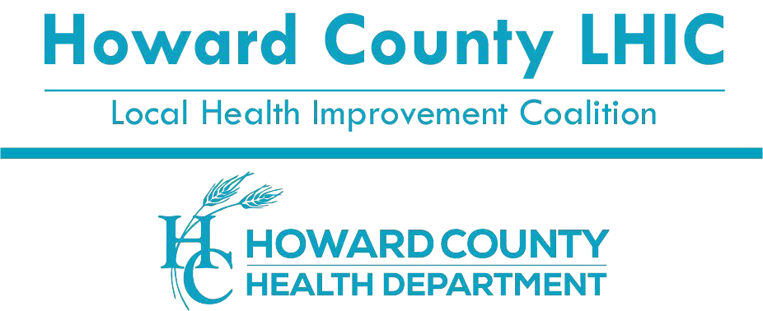
8930 Stanford Blvd |Columbia, MD21045 410.313.6204 - Voice/Relay
410.313.6108 -Fax
1.866.313.6300 –Toll Free
www.hclhic.org

Howard County Local Health Improvement Coalition

Movement Workgroup Meeting

June 27, 2023

12:00pm to 1:00pm

Virtual via Zoom

Minutes

Members Present:

Natalie Hall, Howard County Health Department

Laura Henderson, Howard County Health Department

Julie Kwedar, Maryland Department of Transportation

Tavia Patusky, Columbia Association

Emily Phillips, Howard County Health Department

Michelle Rosenfeld, Howard County Office on Aging, and Independence

Nikki Savoy, Accessible Resources for Independence, Center for Independent Living

Staff Present:

Ashton Jordan, Howard County Local Health Improvement Coalition

Sonya Lloyd, Howard County Local Health Improvement Coalition

Reena Rambharat, Howard County Local Health Improvement Coalition

Topic/Agenda | Discussion | Action / Follow-up
Welcome and Introductions | Ms. Sonya Lloyd, Community Engagement Coordinator, Howard County Local Health Improvement Coalition (HCLHIC), called the meeting to order at 12:03 p.m.  Ms. Lloyd provided a welcome to members in attendance and thanked participants for joining the meeting. She asked members to say one movement activity they planned on doing this Summer.
Announcements | Ms. Lloyd shared the following announcements:  The next full quarterly hybrid LHIC meeting will be at the new time of July 19, 2023, at 8:30 - 10:30am. The agenda is now on the HCLHIC website.  Ms. Lloyd announced the YEP! Make A Run For it free track and field clinics program at Howard Community College (HCC) starting in July 2023 through December 2023 for you people ages 11 to 17.  Ms. Nikki Savory, Accessible Resources for Independence (ARI), said Maryland is going to be part of a national multi-sector learning opportunity for the aging population – will focus on transportation and movement and health disparities will be included in it.  Ms. Tavia Patusky, Columbia Association (CA), announced free physical activity programming at CA. CA now has a calendar of free events for the Summer and shared the link with Movement Group members.  Mr. Ashton Jordan, HCLHIC, shared the new Howard County Health Department (HCHD), Healthy Howard County Campaign and toolkit. The images are now available with different languages. Very general messaging for the community to eat healthy, exercise, get regular check-ups, and quit smoking. | Email any future announcements to  lhic@howardcountymd.gov  Register for next full LHIC meeting: https://www.eventbrite.com/e/2023-hclhic-full-coalition-meetings-tickets-433126562207  Columbia Association calendar: https://columbiaassociation.org/explore-columbia/event-calendar/  Healthy Howard County webpage: https://www.howardcountymd.gov/healthyhowardcounty  Healthy Howard County Toolkit: https://www.dropbox.com/sh/i5jyqxcij9l5h9c/AADtANnsXretCFWgMpctj4Ura?dl=0
Previous Meeting | Ms. Lloyd said that previous meeting minutes can be found on the HCLHIC website. At the last meeting:  Ms. Allison Calkins, Transportation Demand Management Specialist, Office of Transportation in Howard County Government, gave a presentation on Bike Month in May and the Downtown Columbia Partnership (DTCP) goal to encourage people to bike and walk in Downtown Columbia.  Ms. Lloyd gave a brief power point recap of Walktober 2022 to refresh everyone on how we hope to expand and promote even more walk and move events in Howard County this year.  Ms. Natalie Hall, HCHD, led a discussion on Walktober2023. She mentioned incentives and promotion ideas. HCHD purchased 1000 fanny packs and 1000 reflective arm bands as well as, promoting walks to organizations. | Previous meeting minutes can be found: https://www.hclhic.org/home/meeting/2023?cateId=364  Ms. Allison Calkins can be reached with any questions: acalkins@howardcountymd.gov  Ms. Hall can be reached with any questions: nhall@howardcountymd.gov
Community Health Worker Program | Ms. Emily Phillips, the Health Disparities Project Coordinator, HCHD, discussed year 2 of the Community Health Worker Program and recruitment efforts. Ms. Phillips said the HCHD received a grant last year to start a CHW program to reduce health disparities in HC.  The program is now in year 2 and they are recruiting people to work in this program and receive a stipend. Bilingual applicants are especially needed to serve in these communities. The requirement is for the person to live in one of the following zip codes: 21044, 21045, 21075, 20723, 20763, 20794. The HCHD is hoping to recruit 12 additional CHWs. CHWs do not have to get certified. | Email Emily Phillips at ephillips@howardcountymd.gov or call 410-313-0632 if interested.
Walktober Website | Ms. Lloyd said the HoCo Walktober 2023 webpage is now LIVE. Special thanks to Matt Wilson, HCHD Communications, for creating the webpage. Ms. Lloyd asked members to share the web address with their community. There is currently just one walk listed on the page: the Howard County Autism Society Walk.  Ms. Lloyd said Walktober webpage includes a link to a survey to host a walk / move event. We want to encourage people/organizations to click on this link and fill out the form. Once they do that, Mr. Wilson will add that event to the Walktober webpage. | HoCo Walktober 2023 website: https://www.howardcountymd.gov/walktober.
Walktober Interest Letter and Social Media Post | Ms. Lloyd said she and Ms. Hall wrote a HoCo Walktober Interest letter for Movement members to use in inviting communities to host a walk/move event in October. She read the letter and then requested members share this letter with the community.  Ms. Hall led a discussion about the specifics of the letter. We do not want to duplicate efforts, so we need to communicate where the letters are being sent. The goal is to reach out to organizations that would like to hold an event that promotes walking/moving. We would like to advertise their event on the state website and on LHIC’s website.  Members are asked to post social media messages about HoCo Walktober 2023. Ms. Lloyd said there is a QR code on the social media graphic that takes people to the HoCo Walktober2023 webpage. The social media post states: Let's walk, roll, ride, MOVE! It's #Walktober, and we can't wait to get outside this season. Check out our page for inspiration: https://www.howardcountymd.gov/walktober  Ms. Laura Henderson, Women Infants and Children (WIC), asked if we were going to have a spreadsheet that tracked who we were going to send this letter to so that people do not send the letter to the same person twice. She also said she will promote Walktober with WIC clients.  Ms. Hall said to send a list of people with email addresses to Ms. Lloyd and she can send the letter out to avoid duplication of efforts and she will have a spreadsheet tracking who received the letter.  Ms. Julie Kwedar, Maryland Department of Transportation (MDOT), asked if we have reached out to the following groups: Charm City Run Columbia by Snowden River Parkway, Feet First in Columbia, and Road Runners. Ms. Kwedar has a contact at Charm City Run, Megan Fugot, and will reach out to her. Charm City Run also has fun runs for kids.  Ms. Patusky, CA is happy to reach out to Feet First about Walktober and share the Interest Letter with them. These groups sometimes have free events/runs/walks.  Ms. Michelle Rosenfeld, Howard County Office on Aging, and Independence (OAI), said she has worked with Nakia at Feet First in the past and will be happy to share the Walktober Interest Letter with her. | Email lhic@howardcountymd.gov if you would like to donate incentive items for Walktober2023.
Walktober Interest Form | Ms. Lloyd said there is an updated Walktober Interest form (google survey), that people can fill out to have their event added to the Walktober Calendar of Events page. The form also includes a section requesting incentive items for promoting walks that are fanny packs and reflective arm bands.  Walk and Bike to School Month and Day is in October 2023 so that provides great cross promotion potential with Walktober.  Ms. Rosenfeld, OAI is working on getting approval with the 50+ Center Director on having digital signage outside the 50+ Centers and posted to social media to help promote Walktober.  Ms. Henderson, WIC, said we should try and promote Walktober Imaging electronically on tv screens in Dr. offices, waiting rooms and gyms. | Walktober Interest Form Survey: Take Survey!  Walk Bike & Roll to School website: https://www.walkbiketoschool.org/learn-more/about-the-events/about-walk-to-school-day/
Walktober Flyers | Ms. Lloyd said there are translated copies of the Walktober2023 flyers available to share with the community. The flyers are double-sided and printed in the following languages: English, Spanish, Chinese and Korean, with each language having 200 available flyers.  Ms. Lloyd said there is a QR code on the flyer that takes people to the HoCo Walktober2023 webpage. She will share the flyers with Movement members when she sends out the meeting minutes.  The group brainstormed some suggestions on promoting Walktober by sharing the Walktober flyer with Headstart, CAC networks, Howard County Public School System (HCPSS). | Email lhic@howardcountymd.gov to request print copies of the flyers.
Next Steps & Wrap-up | Ms. Lloyd wrapped up the meeting with the following:  - She will send out the minutes in early July.  - The next meeting is scheduled for 12pm on July 25, 2023, via Zoom.  The meeting ended at 12:55pm. | Email Ms. Lloyd with any questions: slloyd@howardcountymd.gov

Respectfully submitted by Sonya Lloyd, MA
Community Engagement Coordinator Howard County Local Health Improvement Coalition

Website: http://www.hclhic.org Social Media: @hclhic

